Sample newsletter and social media content
Use your organisation’s social media accounts, newsletters, blog, website, or intranet to help raise awareness of the health impacts associated with sugary drinks.
Below is suggested copy for use on your communication channels, such as social media, websites, intranets, and newsletters. Accompanying images available as part of the stakeholder kit:
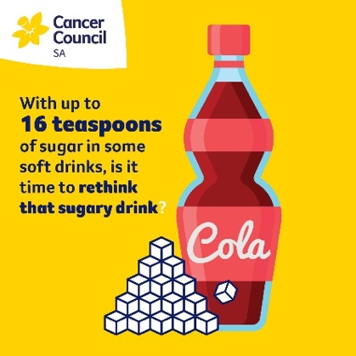 | 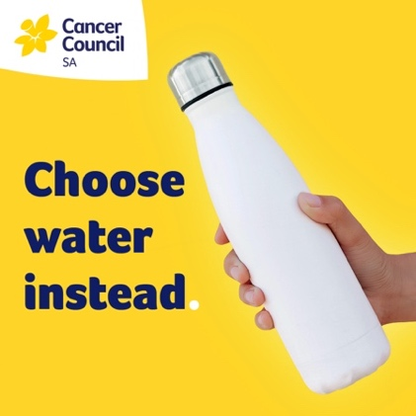 | 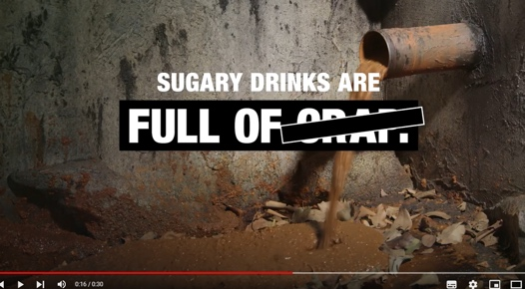
Sugary Drink | Choose water instead | https://youtu.be/TJTOFN_tSfU
Sample newsletter copy
How much sugar is your family drinking? It’s more than you think…
Did you know that a regular 600mL bottle of soft drink contains around 16 teaspoons of sugar?
Consumption of sugary drinks is good for industry’s profits, but bad for the health of our community.
Regularly drinking soft drink and other sugary drinks—like energy drinks, sports drinks, iced teas, and fruit drinks—can lead to weight gain and obesity.
This increases your risk of serious health problems, including type 2 diabetes, heart disease, kidney disease, stroke, and some types of cancer. Sugary drinks can also lead to tooth decay.
Instead of reaching for that sugary drink, choose water instead – naturally sugar free… since forever.
Follow these tips and Rethink Sugary Drinks:
- Find out how much sugar is in your favourite drink at www.cancersa.org.au/rethink-sugary-drinks/
- Be wary of health or nutrition claims – check the sugar content on the nutrition information panel. Download our guide to reading food labels to learn more.
- Learn more about language like Fruit juice vs fruit drink: What is the difference?
- If you're ordering out, ask for water instead of soft drink
- Carry a water bottle so you don’t have to pay for a drink
- If you're thirsty, drink some water first
- Avoid the soft drink aisle in supermarkets and resist drink specials at service stations and convenience stores.
Generic Rethink Sugary Drinks Facebook/Instagram posts
- [upload social tile titled ‘sugary drink’]
We’re supporting @Cancer Council SA’s Rethink Sugary Drinks campaign. Did you know a regular 600mL bottle of soft drink contains around 16 teaspoons of sugar? #RethinkSugaryDrinks
- [link to YouTube video https://youtu.be/TJTOFN_tSfU]
Have you seen the most satisfying video ever? @Cancer Council SA’s new campaign shows how much sugar you’re really drinking. Find out more at https://www.cancersa.org.au/rethink-sugary-drinks #RethinkSugaryDrinks
Generic Rethink Sugary Drinks tweets
- Consumption of sugary drinks is good for industry’s profits, but bad for the health of South Australians. #RethinkSugaryDrinks
Sugary drinks can lead to tooth decay, weight gain and obesity. This summer Cancer Council SA are urging South Australians to make informed health choices. Rethink sugary drinks and choose water instead. #RethinkSugaryDrinks #ChooseWaterInstead
- How much sugar is in your favourite drink? Click here for more. #RethinkSugaryDrinks [upload share graphic titled ‘sugary drink’]
- A regular 600mL bottle of soft drink contains around 16 teaspoons of sugar! #RethinkSugaryDrinks [upload share graphic titled ‘sugary drink’]
- A new campaign from Cancer Council SA highlights how marketing makes sugary drinks seem much more appealing than what they really are. #RethinkSugaryDrinks #ChooseWaterInstead

Workplace Rethink Sugary Drinks Facebook/Instagram post ideas – adapt as required
- At [workplace name], we’ve gone sugary drink free to enable our staff to make healthier choices #RethinkSugaryDrinks [upload photo of healthy vending machine/fridge]
- A regular 600mL bottle of soft drink contains around 16 teaspoons of sugar! We’ve replaced our sugary drinks with water to help our staff stay healthy #RethinkSugaryDrinks [upload photo of healthy vending machine/fridge or share graphic titled ‘sugary drink’]
- Regularly drinking of sugary drinks is unhealthy. That’s why [workplace name] is supporting Cancer Council SA’s Rethink Sugary Drinks campaign and has reduced the amount of soft drink available in our [staffroom/cafeteria/office] #RethinkSugaryDrinks [upload photo of healthy vending machine/fridge or share graphic titled ‘body’]
Workplace Rethink Sugary Drinks Tweet ideas – adapt as required
- 16 teaspoons of sugar in a 600mL soft drink? Our staff are sweet enough! #RethinkSugaryDrinks [upload photo of staff giving a bottle of soft drink the thumbs down]
- There’s nothing sweet about sugary drinks! #RethinkSugaryDrinks [upload photo of staff giving a bottle of soft drink the thumbs down]

Tell Cancer Council SA about your achievements
We’re eager to hear about how you’re helping to promote Rethink Sugary Drinks.
Tag us in your social media posts:
Facebook: @CancerCouncilSA
Instagram: @cancercouncil_sa
Twitter: @cancercouncilsa
Or you can send photos and a brief summary of your achievements to prevention@cancersa.org.au

For more information
- For the latest sugary drink consumption data, research, case studies and other key information and resources, visit the For Professionals page on the Rethink Sugary Drinks website.
- To learn more about the health impacts of regular sugary drink consumption, visit the Facts page on the Rethink Sugary Drinks website.

Rethink Sugary Drink is a partnership between leading health organisations across Australia, to raise awareness of the amount of sugar in sugary drinks and encourage Australians to reduce their consumption. Visit www.rethinksugarydrink.org.au for more information.

